RTRS MANUAL

**TABLE OF CONTENTS**

TABLE OF CONTENTS ………………………………………………………………....…………2

LIST OF FIGURES ………………………………………………………………………………… 7

LIST OF TABLES …………………………………………………………………………………. 8

**1.0 Introduction…………………………………………………………………………………….9**

1.1 Overview of High-Speed Track-Based Ground Test Facilities……………………………….10

1.2 Importance and Historical Background of Rocket Sled Testing………………………………11

**2.0 Test Facilities…………………………………………………………………………………….12**

2.1 Rail Track Rocket Sled (RTRS) facility in India………………………………………………13

2.2 High-Speed Test Tracks in the United States…………………………………………………. 14

2.2.1 Holloman High-Speed Test Track (HHSTT)………………………………………………15

2.2.2 Supersonic Naval Ordnance Research Track (SNORT)…………………………………...12

2.2.3 Supersonic Military Air Research Track (SMART)……………………………………….12

2.2.4 Sandia Test Facilities………………………………………………………………………12

2.3 Test Tracks in the United Kingdom…………………………………………………………….12

2.3.1 Martin-Baker Langford Lodge……………………………………………………………..11

2.3.2 Pendline Test Track………………………………………………………………………...11

2.4 High-Speed Test Tracks in Other Countries…………………………………………………….12

2.4.1 High-Speed Test Track (HSTT) in Japan…………………………………………………...23

2.4.2 Target Ballistic Rail System Dynamic Test Infrastructure (HABRAS) in Turkey…………12

2.4.3 Rocket Sled Track Facilities in France, Russia, South Africa, and Germany………………12

**3.0 Methodical Steps for Precision Testing and Analysis…………………………………………...12**

3.1 Generalized Block Diagram of Rocket Sled Test Facility……………………………………….12

3.2 Requirement of Rocket Sled Test Facility………………………………………………………..11

**4.0 Advantages………………………………………………………………………………………….12**

**5.0 LOADS AND STRUCTURAL ANALYSIS………………………………………………………21**

5.1 QSS Loads…………………………………………………………………………………………12

5.1.1 Thrust and Transmitted Thrust Loads…………………………………………………………12

5.1.2 Aerodynamic Loads……………………………………………………………………………11

5.1.3 Braking Loads………………………………………………………………………………….11

5.1.4 Rail Friction

5.1.5 Pulldown Loads

5.2 Dynamic Loads

5.2.1 Lambda Loads

5.2.2 SIMP Loads

5.2.3 Dynamic Analysis and Design System (DADS)

5.3 Application of Loads

5.4 Structural Analysis

5.4.1 Limit Stress

5.4.2 Safety Factor

5.4.3 Design Stress

5.4.4 Allowable Stress

5.4.5 Margin of Safety (MS)

**6.0 GENERAL SLED DESIGN REQUIREMENTS**

6.1 Fatigue

6.2 Deflection Limits

6.2.1 Aerodynamic Deflection

6.2.2 Sled Body Deflection

6.2.3 Canard Deflection

6.2.4 Knifeblade Deflection

6.3 Natural Frequency Requirements

6.4 Monorail Sled Roll

6.4.1 Sled Roll Defined

6.4.2 Sled Roll Geometry

6.4.3 Sled Roll Design Requirements

6.5 Track Strength

**7.0 SLED COMPONENT DESIGN REQUIREMENTS**

7.1 Slippers

7.1.1 Geometry

7.1.2 Existing Types

7.1.3 Slipper Wear

7.1.4 Slipper Inserts

7.1.5 Design Loads on Slippers

7.1.6 Slipper/Rail Gouging

7.1.7 Rotating Slippers

7.2 Slipper Beams

7.3 Joint Design

7.3.1 Mechanically Fastened Joints

7.3.2 Adhesives

7.3.3 Shims

7.3.4 Friction

7.3.5 Welds

7.4 Handling Provisions

7.4.1 Sleds

7.4.2 Lifting Lugs

7.4.3 Threaded Lifting Eyes

7.4.4 Hoisting Gear

7.4.5 Jacking Gear

7.4.6 Towing and Transportation Gear

7.4.7 Critical Lifts

7.5 Rocket Motor Blast on Pusher Sleds

7.5.1 Mechanical Damage

7.5.2 Thermal Damage

7.6 Rocket Motor Ejecta Protection

7.7 Aerodynamic Heating Protection

7.7.1 Recovered in Air

7.7.2 Not Recovered in Air

7.7.3 Helium Atmosphere

7.8 Propulsion Hardware

7.9 Equipment Mounts

7.10 Electrical Conduit

7.11 Braking

7.11.1 Design Rules

7.11.2 Operational Rules

7.12 Knifeblades

**8.0 OTHER DESIGN REQUIREMENTS**

8.1 Helium Bags

8.1.1 Setup

8.1.2 Diaphragms

8.1.3 Wind Limits

8.1.4 Clearance to Sled and Hardware

8.2 Instrumentation

8.2.1 Isolation Systems

8.2.2 Cable Routing

8.2.3 VMS Head Location and Cabling

8.2.4 Umbilical Connection

8.2.5 Sensor Adjustment

8.2.6 Igniter Considerations

8.2.7 Heat Considerations

8.2.8 Shake Testing

8.3 Track Facility

8.3.1 Rail

8.3.2 Girder

8.3.3 Rail Alignment Criteria

8.4 Concrete Footings

8.4.1 References

8.4.2 Loads

8.4.3 Factor of Safety

8.4.4 Soil Bearing Capacity

8.4.5 Maintain Download

8.4.6 Concrete Mix Specifications

8.4.7 Concrete Strength

8.4.8 Cure Time

8.4.9 Materials Testing

8.4.10 Reinforcing Bar Joints

8.4.11 Anchor Bolts

8.5 Screenboxes

8.5.1 Definition

8.5.2 Backup (Redundant) Screenboxes

8.5.3 Screenbox Supports

**9.0 SLED AND TEST DESIGN BEST PRACTICES**

9.1 Cross-Track Wind Limits

9.1.1 Monorail Sleds

9.1.2 Other Sleds

9.2 Foams

9.3 Velocity Measurements

9.3.1 Time and Position Systems

9.3.1.1 Space-Position Over Time System (SPOTS)

9.3.1.2 Breakwire System

9.3.1.3 RR-200 Fiber-Optic System

9.3.1.4 Velocity Measuring System (VMS)

9.3.2 Photo-Optic Systems

9.4 Velocity Window

9.5 Propulsion

9.6 Sled Design Tips

LIST OF FIGURES

1. **Introduction**

**1.1 Overview of High-Speed Track-Based Ground Test Facilities**

* The study introduces and compares high-speed track-based ground test facilities worldwide for simulating high-speed dynamic events during flight trajectories.
* These facilities perform high-speed flight-testing, delivering controlled conditions for high-velocity impact, acceleration, aerodynamic, and related testing.
* Sleds are designed to carry various test articles, including aircraft, payloads, warheads, missiles, and ballistic systems, achieving velocities from subsonic to hypersonic using solid rocket motors.
* These facilities provide instrumentation for extensive trial data acquisition and analysis for both recovery and non-recovery (impact) trials.
* Detailed descriptions of test facilities in various countries are presented, including India, the United States, Japan, the United Kingdom, France, etc.

**1.2 Importance and Historical Background of Rocket Sled Testing**

* Rapid advancement in designing sophisticated systems necessitates accurate testing techniques.
* High-speed sled track testing is crucial for investigating aircraft munitions systems, hypersonic environments, and aerodynamic effects.

**Ballistic Ranges:**

* + Use solid boosters for firing test articles through sleds on rail tracks or in free flight.
  + Limited by weight, shape, size, and instrumentation possibilities.

**Rocket Sleds:**

* + Accelerate large, heavy test systems using rockets mounted on sleds over rail tracks.
  + Capable of impact testing missiles, warheads, aircraft, and other weapon systems.

**Historical Examples:**

* + Rocket sleds were extensively used during the early Cold War for acceleration due to the risk of using heavy articles directly in pilot aircraft.
  + Notable achievements include launching a winged strategic RM through a tunnel during World War II and achieving a Mach 8.5 speed record at Holloman Air Force Base in 2003.

**2.0 Test Facilities**

**2.1 Rail Track Rocket Sled (RTRS) facility in India**

Location and Establishment: The Rail Track Rocket Sled (RTRS) facility is situated within the Terminal Ballistic Research Lab (TBRL) under the Defence Research and Development Organisation (DRDO) in Haryana, India. It has been operational since its establishment in 1988.

Structure and Components:

* The RTRS facility features a levelled rail track system where test articles, termed payloads, are mounted onto sleds specifically designed for testing purposes.
* Rocket motors, arranged in clusters, are utilized to generate the necessary dynamic conditions required for acceleration along the rail track.

Capabilities:

* The facility boasts a supersonic penta-rail structure, which consists of five rail lines. This rail system is precision-aligned and engineered to withstand high loads.
* Over the years, the track has been expanded to a length of 4 kilometres, accommodating multiple lines with wider gauges and continuous welded tracks to cater to a variety of payloads.
* The RTRS facility is equipped to conduct both aerodynamic and kinematic studies on test articles, providing a controlled environment for research and evaluation.

Trials and Testing:

* Trials conducted at the RTRS facility include both recovery and non-recovery trials, catering to a wide range of payloads differing in mass and dimensions.
* These trials are carried out year-round, with a significant number of trials conducted since its inception, totalling over 1000 trials to date.
* The facility has achieved velocities up to Mach 2 in non-recovery trials, showcasing its capability to simulate high-speed conditions.

Customized Testing:

* The RTRS facility operates as a captive test facility, meaning it is utilized by various users for their specific testing requirements.
* Each test is meticulously planned according to the user's specifications, ensuring that essential test requirements are addressed.

Data Acquisition and Applications:

* Data from tests are acquired through both on-board and ground instrumentation modes and subsequently processed for performance assessment.
* The facility utilizes photo-instrumentation, such as images and videos, to capture major events during tests, including impact, parachute deployment, ejection, release, and payload separation.
* Major applications of the RTRS facility span across various sectors, including proximity fuze testing, ballistics studies, missile systems performance testing, evaluation of warheads and explosives, parachute recovery systems, navigation systems, armament systems, and fighter aircraft escape systems.

In essence, the Rail Track Rocket Sled (RTRS) facility in India serves as a crucial resource for conducting research, evaluation, and testing in the fields of armament, missile systems, and aerospace technology, with its advanced infrastructure and comprehensive capabilities

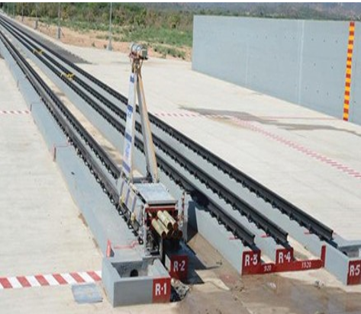

Fig 2.1: Penta Rail Track RTRS

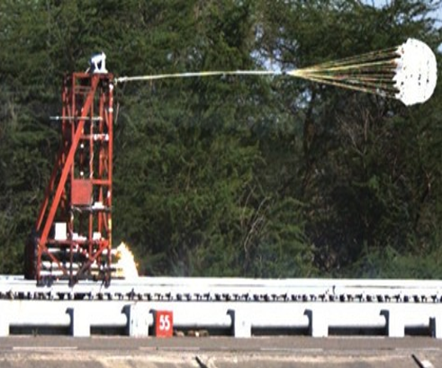

Fig 2.2: Parachute Testing At RTRS

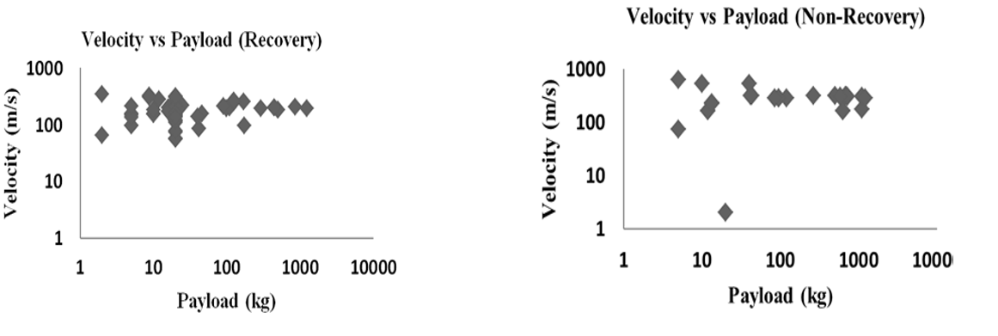

Fig 2.3: **Trials capability at RTRS for recovery and non-recovery trials (representative data in log scale).**

**2.2 High-Speed Test Tracks in the United States**

**2.2.1 Holloman High-Speed Test Track (HHSTT)** Located in Holloman AFB, New Mexico, the Holloman High-Speed Test Track (HHSTT) was established in 1954. It's one of the longest and most capable test tracks globally, spanning approximately 15,536 meters. Capable of conducting rocket sled testing, with parallel rails (R1 and R2) having a gauge of 2.1336 meters and an additional third rail (R3) of 6,100 meters in length with a gauge of 0.66802 meters. The facility holds the record for testing an 11.34 kg payload up to Mach 8 in 1982. It hosts the Holloman Maglev track since 2004, dedicated to testing ballistic systems such as missiles and munitions.

**2.2.2 Supersonic Naval Ordnance Research Track (SNORT)** Located at the US Naval Ordnance Test Station, China Lake, California, the Supersonic Naval Ordnance Research Track (SNORT) was established in 1953. It features approximately 6,598 meters of precision-aligned, two-rail parallel track. SNORT is used for captive flight testing of various military systems including rockets, missiles, warheads, aircraft, and their components. It achieved a world record for producing the highest thrust for a rocket sled test and achieving high accelerations.

**2.2.3 Supersonic Military Air Research Track (SMART)** Located at Holloman AFB, New Mexico, the Supersonic Military Air Research Track (SMART) is a rocket sled test track used for a wide range of high-speed testing. It's one of the few facilities capable of testing full-scale aircraft ejection seats and crash test dummies under high-speed conditions.

**2.2.4 Sandia Test Facilities** The Sandia Test Facilities, located in Kirtland AFB, Albuquerque, New Mexico, consist of Sandia 1 and Sandia 2 facilities. Sandia 1, established in 1951, features a track length of 610 meters. Sandia 2, extended in 1966, spans 3,048 meters with a gauge of 0.56 meters. Capabilities include high-velocity impact trials, testing of small and large test articles, certification for handling various weights and velocities. Sandia sled-testing technique has achieved velocities up to Mach 6.53.

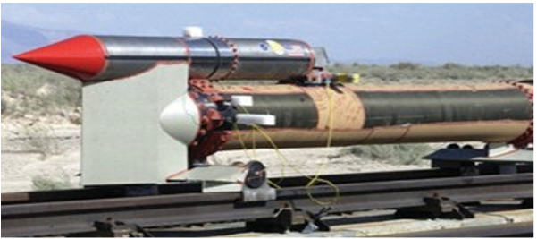

Fig 2.4: **HHSTT Rocket Sled System,**

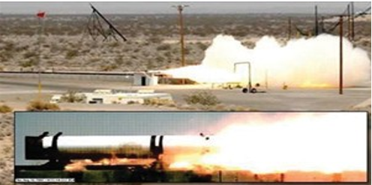

Fig 2.5: **SNORT**

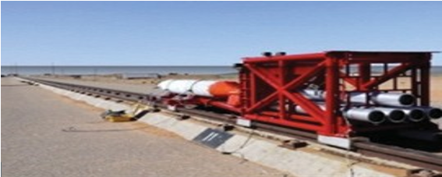

Fig 2.6: **Sandia Rocket Sled Track Facility**

**2.3 Test Tracks in the United Kingdom**

**2.3.1 Martin-Baker Langford Lodge** Established in 1971 by Martin-Baker Company, Martin-Baker Langford Lodge is located at Langford Lodge, Northern Ireland. It features an 1829-meter long track known for its straightness within a tolerance of 0.00025 meters over 38 meters, ensuring high accuracy for high-speed traveling. Primarily used for qualifying escape systems, such as the Mk 16A ejection seat for the Eurofighter Typhoon, tested up to a speed range of 308 m/s. Conducts various test activities including parachute deployment, penetration testing, and seat ejection testing, along with research, design, and development of ejection seats using specially fabricated test vehicles.

**2.3.2 Pendline Test Track** Located at MOD Pendine military range in West Wales, Pendline Test Track consists of three test tracks: Short Track Test (STT), Impact Test Track, and Long Test Track (LTT). STT is capable of testing small systems with a rail track length of 200 meters, accommodating velocities ranging from 500 m/s for 45 kg payloads to 250 m/s for 250 kg payloads. The impact test track was extended to 450 meters in 1989 for testing small payloads within a speed range of 120 m/s. LTT extends up to 1500 meters with a rail gauge of 0.3048 meters, used for high-speed rail track dynamic trials of warheads, ground attack systems, and missiles, achieving speeds up to Mach 3 with accelerations of 130 g.

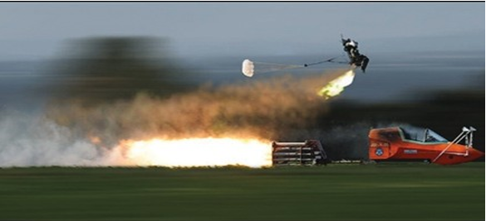

**Fig 2.7. Martin Baker Langford Lodge facility**

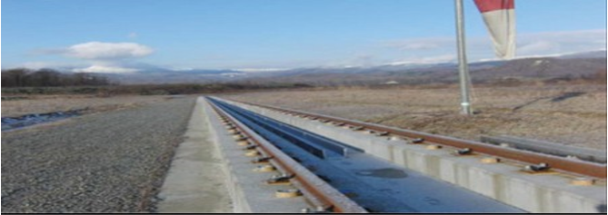

**Fig 2.8 HSTT test facility of 3000 m length**

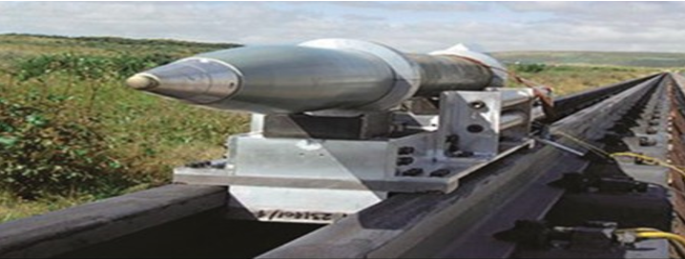

**Fig 2.9 Pendline long test track (LTT) facility**

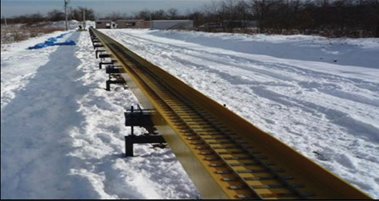

**Fig 2.10: SSTT test facility of 100 m length**

**2.4 High-Speed Test Tracks in Other Countries**

**2.4.1 High-Speed Test Track (HSTT) in Japan** The High-Speed Test Track (HSTT) in Shiraoi town, Hokkaido, Japan, was established in 2009 primarily for academic use. Initially, it featured a prototype 300-meter long rail track, later extended to 3000 meters. Capable of achieving a Mach number of 0.645 and is used for acceleration/deceleration studies utilizing water brake and lubrication methods. Additionally, it includes a sub-scale test track (SSTT) of 100 meters in length for developing aerodynamic measurement systems, particularly for ground effect in spacecraft.

**2.4.2 Target Ballistic Rail System Dynamic Test Infrastructure (HABRAS) in Turkey** The Target Ballistic Rail System Dynamic Test Infrastructure (HABRAS) in Ankara, Turkey, is a supersonic European test track facility. Established in June 2017 at the Scientific and Technological Research Council of Turkey (TUBITAK), it spans 2000 meters in length, capable of achieving speeds up to 555.5 m/s (Mach 1.6). Used for testing cruise missiles with high-explosive warheads and plans to expand its use for testing rocket engines and ejection seat-based escape systems.

**2.4.3 Rocket Sled Track Facilities in France, Russia, South Africa, and Germany** Facilities in France, Russia, South Africa, and Germany contribute to high-speed testing and research in various capacities. The Centre Dessais Des Landes Single Rail in Biscarrosse, France, provides telemetry, remote control, and trajectography for missile flight testing. Russia's test facility located 50 km away from Zvezda features a 2500-meter long segmented rail track. The Alkantpan Rocket Sled Range in South Africa boasts a 200-meter rail track for dynamic testing. Germany features a limited but notable facility for track-based testing with I-Beam rail type.

These facilities play a crucial role in advancing aerospace and armament systems by providing a controlled environment for high-speed testing. With continuous upgrades and enhancements, they contribute significantly to the development and improvement of various systems and subsystems.

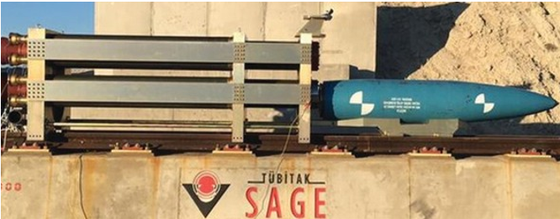

**Fig 2.11 HABRAS TEST TRACK FACILITY**

**3.0 Methodical Steps for Precision Testing and Analysis**

**3.1**Generalized Block Diagram of Rocket Sled Based Track Test Facility

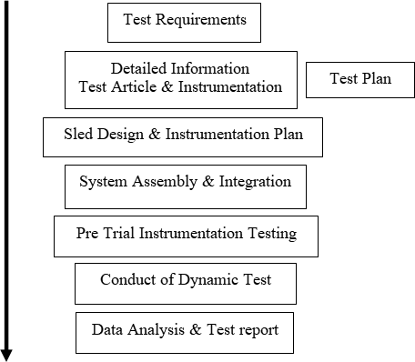

**3.2 Requirement of Rocket Sled Test Facility**

**A track-based rocket sled test facility includes**:

* Precision aligned test track.
* Sled fabrication and qualification facilities.
* Instrumentation and data recording facilities (on-board and through telemetry).
* Data processing and analysis capabilities.
* High-speed videography.

The sled operates on the rail track riding over rails on shoes called slippers. The size and configuration of the sled vary according to test needs and can be recovered for post-run inspection, reuse, and evaluation except for high-speed impacts or destructive explosive trials.

Sleds are propelled by solid fuel rocket motors (RMs) for high acceleration. They can carry various items like test articles, RMs, explosives, instrumentation, cameras, etc.

To ensure confidence in test equipment or articles, sleds are used under various conditions of velocity, shock, acceleration, aerodynamic effects, and weather-related effects. Analytical study of sleds is essential due to the uniqueness, cost, and risk of trials.

**4.0 Advantages of Rocket Sled Based Track Test Facility**

**Track-based test facilities offer several advantages:**

* Capability to carry and accelerate test articles in a wide range of speeds from subsonic to hypersonic.
* Ground level testing of captive flight systems fulfilling user’s requirements.
* Close monitoring of test articles during trials for further observation and analysis.
* Recoverability of test items used.
* Elimination of the possibility of losing article for test (AFT) in real-time.
* Design flexibility to provide maximum data for each test and simulate unique scenarios.
* Effective and economical post-analysis in recovery trials for repetitive testing and assessment under simulated environmental conditions.

With the increasing cost and complexity of development, integration, and testing of test articles, high-speed rocket sled-based test facilities are being widely used as ground test methods

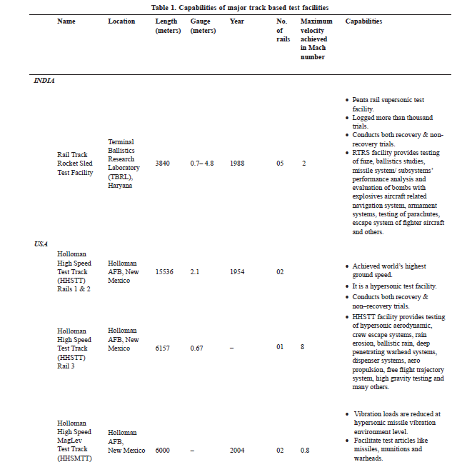

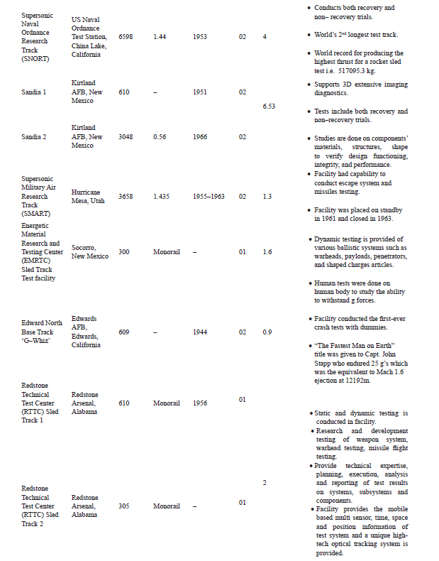

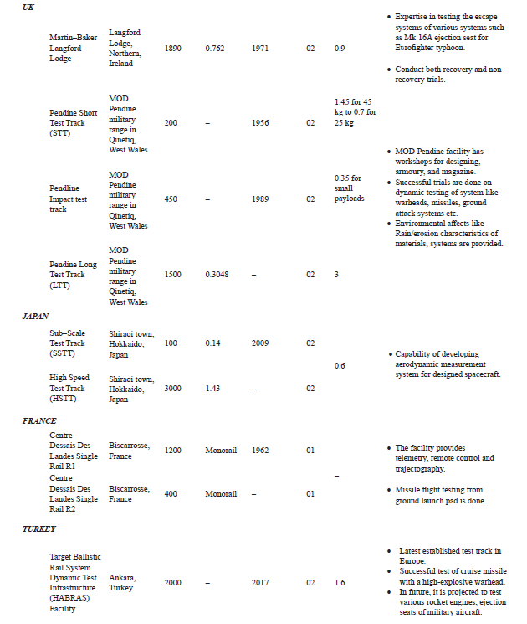

Fig 4.1: Capabality of major Track Test Facilities

5.0. **LOADS AND STRUCTURAL ANALYSIS**

The design of rocket sleds requires the engineer to evaluate complex loads and numerous load conditions which are imposed on the sleds as they travel along the track. These loads have been divided into two groups based on their duration and are defined as quasi-steady state (QSS) and dynamic. In this chapter, we discuss how to derive loads for rocket sled design, how to apply the loads, and how to evaluate the sled’s structural adequacy.

5.1. **QSS Loads**

These are defined as loads due to aerodynamic lift and drag, symmetrical thrust, unsymmetrical thrust, braking, inertial forces in the down track direction, and centripetal loads over the pulldown. The following sections discuss the different QSS loads.

5.1.1. **Thrust and Transmitted Thrust Loads**

Thrust (T) is defined as the total rocket motor propulsive force for the design condition being analyzed.

Transmitted Thrust (TT) is defined as the effective force transmitted from one sled to another sled.

Transmitted Thrust has been measured on several sled systems, with amplification factors ranging from 1.3 to 1.5.

The highest measured oscillatory transmitted thrust typically occurs at burnout of the rocket motors.

Use a step load factor of 2.0 near the rocket motor attachment.

Special definitions and applications of thrust factors are detailed in Tables 1.1, 1.2, and 1.3.

5.1.2. **Aerodynamic Loads**

Aerodynamic data should reference an ambient static pressure of 12.7 psia, an ambient temperature of 70°F, and a corresponding air density of 0.0020086 slugs/ft³.

The corresponding density for helium is 0.0002774 slugs/ft³.

5.1.2.1. **Lift (and Side) Loads**

Test Track Engineering must approve all independently determined aerodynamic lift loads.

Lift estimates are best obtained from empirical data or semi-empirical component build-up methods.

CFD analyses are becoming more common but should be used cautiously due to limited correlation with full-scale sled data.

Wind tunnel results validated with full-scale track data are reliable for supersonic speeds.

Specific aerodynamic conditions affecting rocket sled lift include subsonic/transonic ground effect, shock reflections from the ground plane, and choked flow under dual rail and narrow gauge sleds.

5.1.2.2. **Drag Loads**

Test Track Engineering must approve all independently determined aerodynamic drag forces.

Drag estimates typically come from empirical data or semi-empirical methods.

CFD and wind tunnel drag coefficient estimates are usually lower than actual sled values.

The 70% Rule can be used for preliminary drag estimates for sled combinations or “sled trains.”

5.1.2.3. **Aerodynamic Effects of Sled Deflection & Sled Alignment**

Effects of sled structural deflection and alignment are pronounced in the lateral plane for monorail sleds.

Small lateral aerodynamic angles can generate side loads and roll moments, potentially causing asymmetrical slipper wear and worsening sled roll conditions.

Dual rail and narrow gauge sleds are generally less susceptible but still require consideration for large payloads.

5.1.2.4. **Asymmetric Shock Wave Reflections (Monorail Sleds)**

When monorail sleds operate on B rail, shock waves reflect from C rail and its girder, potentially causing sled roll problems.

This issue has been mitigated by filling the narrow gauge trough with water.

Transient shock waves from girder tiedowns or isolated stationary structures do not significantly affect sleds.

5.1.3. **Braking Loads**

All brake structures, fixtures, and sled structures shall be designed using specific load factors.

5.1.3.1. **Initial Braking Load Factor**

A load factor of 2.0 shall be used for brake design due to the step load characteristic at entry.

5.1.3.2. **Reduced Braking Load Factor** 5.1.3.2.1. **No Medium Change**

The load factor may be reduced to 1.0 once steady-state loading is reached, as determined by a dynamic analysis.

5.1.3.2.2. **Medium Change**

The reduced load factor technique applies to medium changes. The previous brake load is multiplied by 1.0, and the new load above the previous load is multiplied by 2.0.

Formula: 𝐹BRAKE@CHANGE=𝐹PREVIOUS×1.0+(𝐹NEW−𝐹PREVIOUS)×2.

5.1.3.2.3. **Other Cases**

If a dynamic loading analysis is not available, use a factor of 2.0 at water brake entry, tapering off to 1.5 at water brake exit.

5.1.4. **Rail Friction**

Rail friction is generally small and often ignored for structural design but is important for performance calculations.

Friction loads from extreme QSS or dynamic loads should be considered in the vicinity of the slippers.

5.1.5. **Pulldown Loads**

Pulldown rail systems divert sleds and sled hardware away from end game activities.

Required pulldown loads include centripetal inertial force, vertical and lateral dynamic loads, aerodynamic loads, thrust, and/or transmitted thrust.

A load amplification factor of 2.0 is used for sudden changes from straight rail to constant radius pulldown, which can be reduced to 1.0 with a smooth transition.

5.2. **Dynamic Loads**

Defined as inertial forces in the vertical and lateral direction caused by sled bouncing on the rails due to motor thrust transients, rail roughness, and/or oscillating aerodynamics.

Typically applied statically for structural analysis but are actually transient.

5.2.1. **Lambda Loads**

5.2.1.1. **Calculations**

The Lambda load is calculated by multiplying the sled weight by the Lambda factor.

Vertical direction: 1.0 × Lambda load

Lateral direction: 0.6 × Lambda load

Applied through the center of gravity or as a distributed load consistent with sled mass distribution.

Symmetric loads: vertical up = vertical down, lateral right = lateral left.

5.2.1.2. **History**

The Lambda method has been used for over 15 years to estimate dynamic loads for sled design.

Initially intended for rough sizing, it has proven effective for final dynamic load estimation.

Engineers often use body loads to apply Lambda loads instead of point loads at the center of gravity.

5.2.1.3. **Cautions**

Caution is needed when designing significantly different structures from a “typical” sled structure.

The Lambda method may not be suitable for very flexible or unusually stiff sled configurations.

5.2.2. **SIMP Loads**

The Sled Impact Parameter (SIMP) technique can provide more realistic dynamic load estimates for dual rail sleds.

Considers parameters such as sled stiffness, load, and mass distributions, and rail roughness.

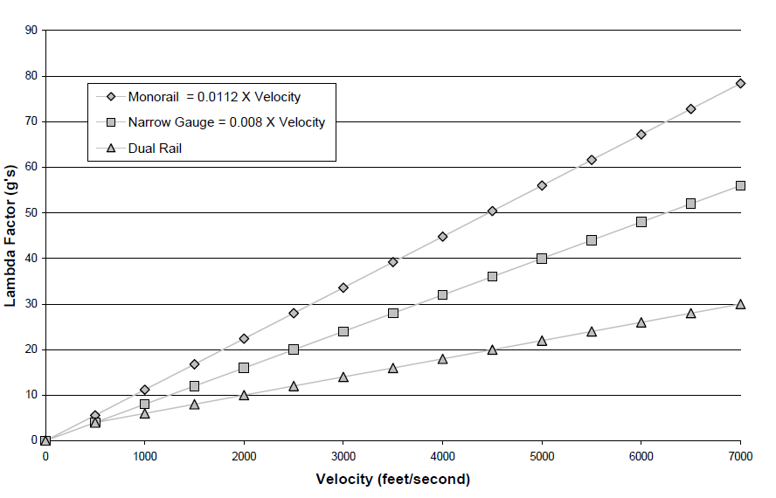

Fig 5.1: Lambda Factor

**5.2.3. Dynamic Analysis and Design System (DADS)**

A third method of estimating dynamic loads is the Dynamic Analysis and Design System (DADS) technique, typically reserved for complex or specialized problems or sled designs necessitating stringent parameter control such as weight.

Due to its complexity and time-consuming nature, DADS utilization in normal sled design processes is limited.

Nevertheless, DADS is an accepted method for estimating vertical and lateral dynamic loads.

All DADS analyses must be closely monitored and approved by TGTD.

The version of DADS used by the Test Track is modified and verified to simulate the track environment, potentially differing from off-the-shelf packages.

Consultation with TGTD is necessary before initiating load estimation using DADS.

**5.3. Application of Loads**

The magnitude of described loads and load factors depends on the point in the trajectory being considered, termed as a design condition.

Applicable design conditions listed in Tables 1.1, 1.2, and 1.3, along with any other significant conditions, shall be evaluated for hardware tested at the Track.

Different design conditions may cause concerns for various areas of a sled structure; for instance, max lift may influence the attachment design of a cantilevered nose cone, while max velocity may control the sipper design.

**5.4. Structural Analysis**

**5.4.1. Limit Stress**: The maximum stress in a structural member considering all applicable design conditions, based on the Distortion-Energy Theory (Henky-von Mises). Bearing stress is an exception.

**5.4.2. Safety Factor**: A factor multiplied by the limit stress to account for unknowns in material properties, fabrication quality, dynamic load uncertainty, and strength degradation from operational usage, handling, and/or outside storage.

**5.4.3. Design Stress**: The product of the limit stress in a structural member and the appropriate safety factor.

**5.4.4. Allowable Stress**: The maximum stress a structural member can withstand without failure based on its material properties. For ductile materials (elongation > 5%), the maximum design stress shall not exceed the allowable stress. Use of brittle materials (elongation < 5%) is not recommended and must be approved by the TGTM Chief. Also note that the allowable stress will need to be adjusted when designing for fatigue.

**5.4.5. Margin of Safety (MS):** The measure of adequacy of a design, computed as (Allowable Stress)/(Design Stress) – 1.

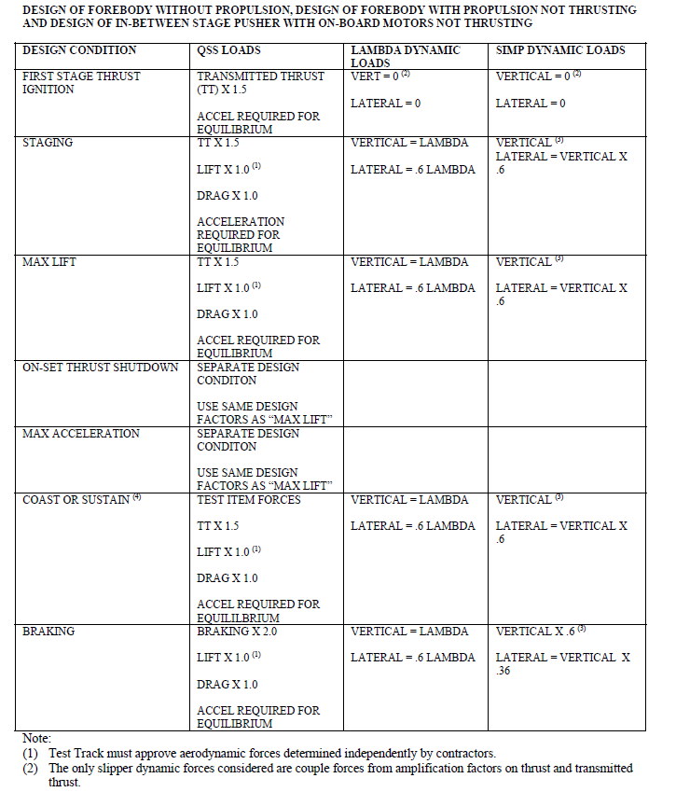

Note:

1. Test Track must approve aerodynamic forces determined independently by contractors.
2. The only slipper dynamic forces considered are couple forces from amplification factors on thrust and transmitted thrust.

Fig 5.2 Table



Fig 5.3: **DESIGN OF FOREBODY WITH ON-BOARD PROPULSION THRUSTING AND DESIGN OF PUSHER WITH ON- BOARD PROPULSION THRUSTING (NO FOREBODY)**



**Fig 5.4 DESIGN OF PUSHER PROPELLING A FOREBODY**

**6.0. GENERAL SLED DESIGN REQUIREMENTS**

**6.1. Fatigue**: Reusable sleds expected to cost approximately $1M or more must withstand at least 100 runs. The number of cycles per sled run shall be estimated by multiplying the nominal sled run time by 100 cycles per second if frequency data are not available.

**6.2. Deflection Limits**

**6.2.1. Aerodynamic Deflection**: Sleds with cantilevered or critical aerodynamic sections shall be designed such that the cantilever or critical aerodynamic section does not deflect vertically or laterally more than 1 deg when QSS and dynamic design loads are applied.

**6.2.2. Sled Body Deflection**: Sufficient body stiffness in the design shall be included so as not to allow the sled body to deform, when subjected to QSS and dynamic design loads, such that the slippers will “lock-up” on the rail in the pitch or yaw planes, i.e. slipper gap has been eliminated.

**6.2.3. Canard Deflection**: Canards shall be designed such that the deflection due to QSS and dynamic design loads shall not cause the canard to deflect more than 1 degree from the intended design angle.

**6.2.4. Knifeblade Deflection**: Knifeblades shall be designed such that the knifeblade tip does not deflect more than 1/4 inches when QSS and dynamic design loads are applied.

**6.3. Natural Frequency Requirements**: Sleds shall be designed with the lowest possible natural frequency to minimize rail impact loading yet high enough to avoid excessive deflection as noted above.

**6.4. Monorail Sled Roll**

**6.4.1. Sled Roll Defined**: In monorail sled testing, quasi-steady loads in the cross track direction apply a roll moment to the rail because these loads are applied above the location they are reacted, i.e. the railhead.

**6.4.2. Sled Roll Geometry**: Past experience has shown that slipper wear of up to 0.125” is not uncommon for monorail tests; however, test abnormalities have caused more slipper wear and sled roll.

**6.4.3. Sled Roll Design Requirements**

When contact is required for a successful sled test such as with knifeblades, band cutters, water braking trays, etc., all hardware shall be designed to function properly with a sled roll of up to 6 degrees.

When clearance is required for a successful sled test such as with a sled clearing a screenbox, knifeblades clearing water bags in braking trays, etc., all hardware shall be designed to function properly with a sled roll of up to 6 degrees.

**6.5. TRACK STRENGTH**

**Ohio State University (OSU) Evaluation**: The static and dynamic strength as determined from these References are shown in Table 2.2.

**Estimated and Measured Loads**: Estimated and measured loads applied to the rail during various sled tests are shown in Table 2.3.

**Slipper Design and Lateral Loads**: Due to the slipper design, lateral loads on the slipper beam of dual rail sleds are never reacted at both rails simultaneously. Instead, both rails react these loads intermittently in a random fashion.

**Outrigger Sleds**: For outrigger sleds, the rail above which the main sled body operates takes the lateral loads in both directions.

**Monorail Sleds**: Force couples resulting from sled roll must be incorporated into the sled and track analysis.

**Design Requirements**: Sleds shall be designed such that quasi-steady vertical and lateral single-point loads do not exceed those shown in Figure 2.4. Note that these loads are generally less than the failure loads determined in Reference 2.2.

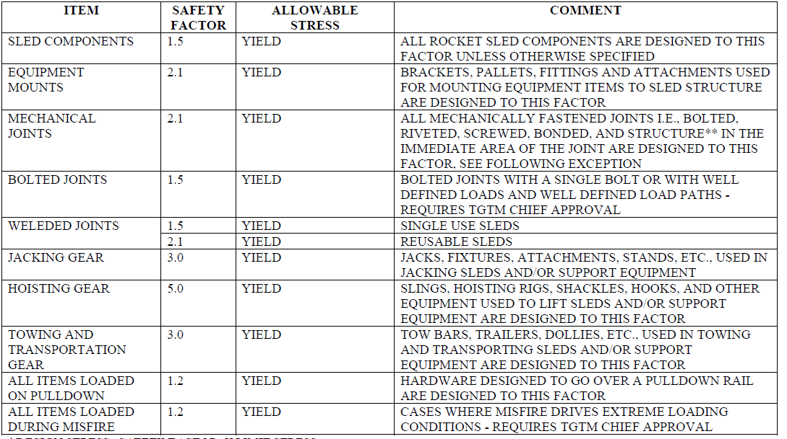

Fig 6.1: SAFETY FACTORS

\**DESIGN STRESS=SAFETY FACTOR X LIMIT STRESS*

** *STRUCTURE IN THE IMMEDIATE AREA OF THE JOINT IMPLIES STRUCTURE THAT EXPERIENCES THE SAME LOADING AS THE FASTENER.FOR EXAMPLE, WHEN ANALYZING THE HOLE THAT A FASTENER GOES THROUGH THIS SAFETY FACTOR WOULD APPLY TO THE SHEAR, SHEAR TEAROUT, BEARING, TENSILE, AND BOLT HEAD PULL THRU*

**7.0 Sled Component Design Requirement**

**7.1. SLIPPERS**

**7.1.1. Geometry**

**7.1.1.1. Slipper Clearance Around Track Hardware:**

Provide clearance to avoid interference between slippers and track hardware.

Consider slipper wear and sled roll.

Critical clearance at top of vertical tiedown studs at WL -2.75.

Other potential interference from items like screen boxes, camera mirrors, etc.

**7.1.1.2. Slipper Gaps:**

Ideal gap: 0.125 inches.

Vertical and lateral slipper gaps: 0.110 inches to 0.140 inches.

**7.1.1.3. Web Bearing Slippers:**

Designs avoiding slipper lips contacting rail web or raised lettering require approval.

**7.1.2. Existing Types of Slippers**

**7.1.2.1. Full Slippers:**

One-piece, installed at track ends, used on dual rail pusher sleds.

**7.1.2.2. Half Slippers:**

Wrap around inside half of rail head, used on ejection forebody sleds.

**7.1.2.3. Split Full Slippers:**

Similar to full slippers, but installable anywhere on the track.

**7.1.2.4. Wrap Around Slippers:**

Bent from plate material, used on slower speed disposable sleds.

**7.1.2.5. Machined Slippers:**

Machined or welded halves, used on high-speed disposable or reusable sleds.

**7.1.2.6. Cast Slippers:**

Made from castings, used as housings for reusable sleds.

**7.1.2.7. Outrigger Slippers:**

Provide roll stability to large monorail sleds, typically react vertical loads.

**7.1.2.8. Bogie Beams:**

Used on very large heavy sleds to spread load to multiple slippers.

**7.1.3. Slipper Wear:**

Caused by sliding contact with rail, increases with velocity.

Must be considered in slipper and test designs.

**7.1.4. Slipper Inserts:**

New designs for reusable sleds to incorporate replaceable inserts when applicable.

Approval required for use above 4,000 ft/s.

**7.1.5. Design Loads on Slippers:**

Dual rail, narrow gauge, outrigger wing, and monorail slippers designed to transfer vertical and lateral loads.

Dual rail slippers may have isolated slippers and/or load pads.

**7.1.6. Slipper/Rail Gouging:**

Occurs at velocities above 5000 fps, preventive measures needed.

**7.1.7. Rotating Slippers:**

Designs allowing rotation must adhere to wear criteria.

**7.2. SLIPPER BEAMS**

**7.2.1. Configurations:**

Ends accommodate standard slipper assemblies when applicable.

**7.2.2. Lateral Load Reaction:**

Variations in track gauge accommodated up to plus or minus 0.10 inches.

**7.2.3. Internal Conduit:**

Not less than 1.0 inch outside diameter, for electrical wiring bundles.

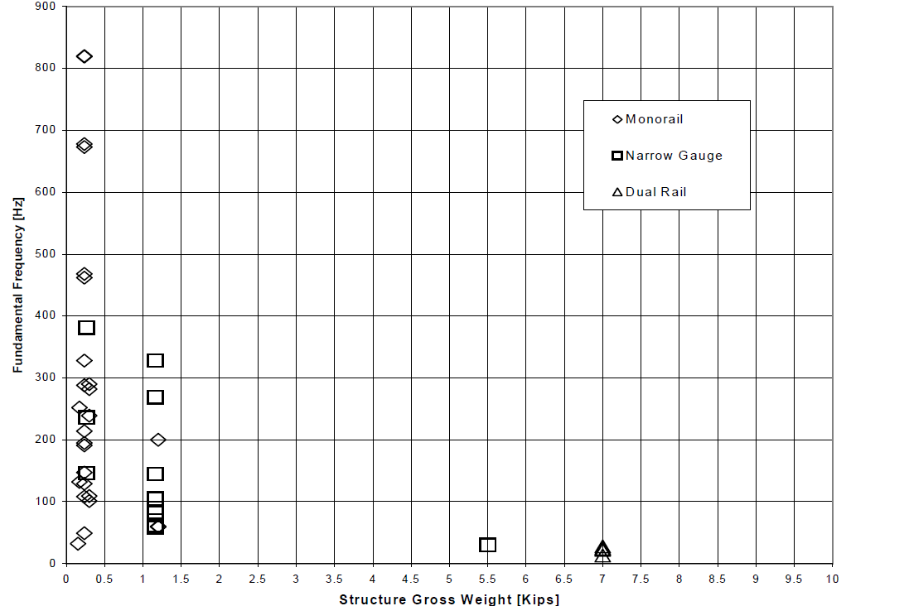

Fig 7.1: SLED NATURAL FREQUENCIES DEMONSTRATED AT HHSTT

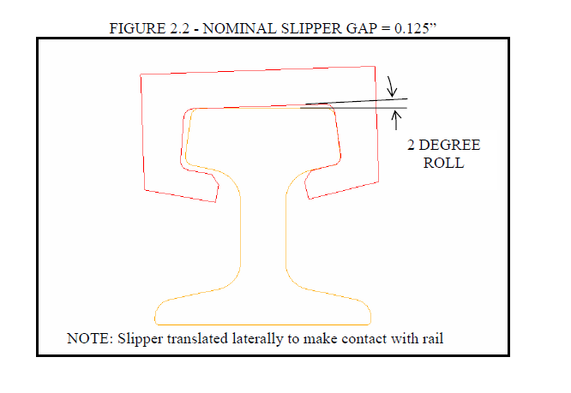

Fig 7.2: NOMINAL SLIPPER GAP = 0.125”

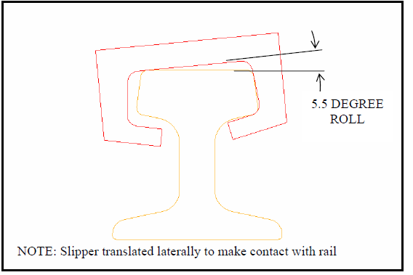

FIGURE 7.3 - NOMINAL SLIPPER GAP = 0.125”

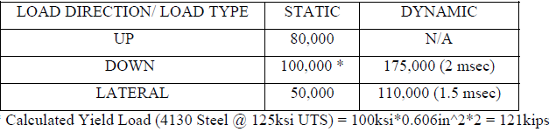

FIGURE 7.3 - MEASURED TRACK FAILURE LOADS ON SINGLE TIEDOWN FIXTURE (SIMILAR TO TS 5000 - TS 35000 FIXTURES)

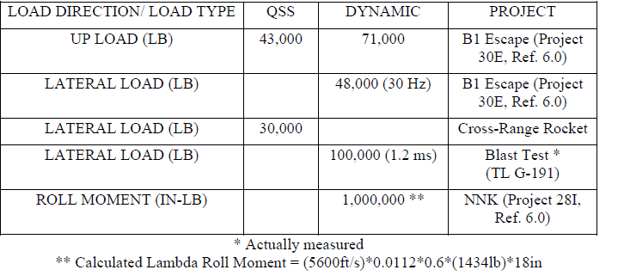

FIGURE 7.4 - SLED LOADS APPLIED TO RAIL

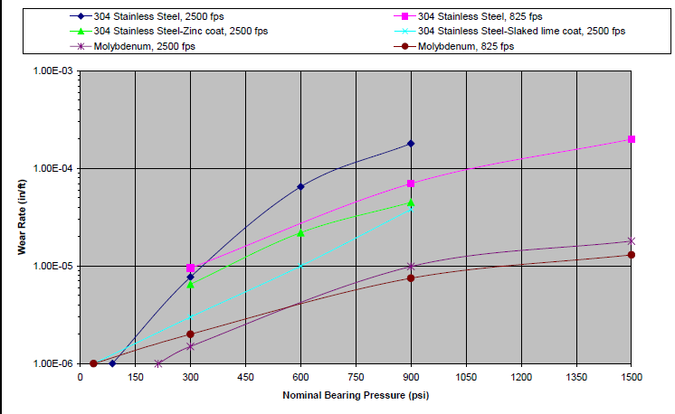

Fig 7.5 – Wear Rate as Affected by Various Parameters (Load Application Dist. 2k ft)

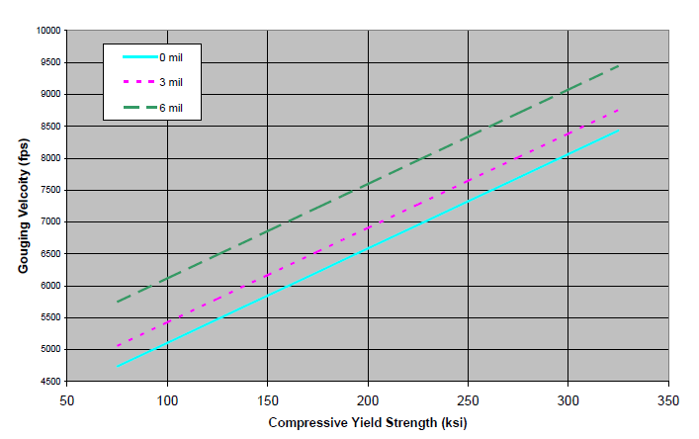

Fig 7.6 – Velocity at Initiation of Gouging Versus Compressive Yield Strength for Steel Slippers Impacting a Rail with Red Oxide Primer

**7.3. JOINT DESIGN**

**7.3.1. Mechanically Fastened Joints:**

**7.3.1.1. Shear Loading Guidelines:**

* + - Determine bearing area as the product of the fastener diameter and plate thickness.
    - Optimal edge distance: center of fastener holes should be at least 200% of fastener diameter from edge.
    - Minimum edge distance: center of fastener holes should be at least 150% of fastener diameter from edge.
    - Edge distances less than 150% require substantiation through adequate testing.
    - Part thickness with a fastener hole should be greater than 18% of fastener hole diameter.
    - Determine bearing stress as shear load to bearing area ratio.

**7.3.1.1.2. Shear Tearout Area Evaluation:**

* + - Determine shear tear-out area as the product of distance LST, part thickness, and 2.
    - Determine shear stress as shear load to shear tear-out area ratio.

**7.3.1.1.3. Fastener Shear Area Evaluation:**

* + - Determine fastener shear area through threads based on nominal minor diameter.
    - Determine fastener shear stress as shear load to fastener shear area ratio.

**7.3.1.2. Tensile Loading Guidelines:**

* + - * Determine fastener tensile area based on nominal minor diameter.
      * Determine pull-through area as product of fastener head/nut perimeter and part thickness.
      * Determine pull through shear stress as tensile load to pull through area ratio.

**7.3.1.3. Bolt Head to Shank Fillet Clearance:**

* + 1. Provide clearance for bolt head radius by chamfered feature in part design or chamfered washer.

**7.3.1.4. Torque Value Specification:**

* + - * torque value for all fasteners on engineering drawings.
      * Use torque value equation T = P * K * D, where K is the nut factor and D is the nominal shank diameter.

**7.3.1.4.1. Tensile Loaded Fasteners:**

* + - * Set preload level at 70% of allowable fastener load.
      * Alternatively, perform detailed joint analysis for desired preload level exceeding method

**7.3.1.4.2. Shear and Combined Loaded Fasteners:**

* + - * Preload to a value not exceeding 5% of allowable fastener tensile load.
      * Use interaction formula RS3 + RT2 < 1.0 for combined shear and tension loading evaluation.

**7.3.1.5. Fastener Hardware Requirement:**

* + 1. Use aircraft-quality NAS, AN, and MS fastener hardware for all Track applications.

**7.3.1.6. Locking Features:**

* + 1. Safetied all threaded fasteners by safety wire, lock nuts, or other approved methods.
    2. Threaded fasteners should protrude a minimum of two full threads beyond lock nuts.
    3. Joints with single point of failure should have redundant locking mechanisms.
    4. Adhesives may be used as secondary locking mechanism or as primary with approval.

**7.3.2. Adhesives:**

* + Adhesive capability not qualified in high vibration environment for sled testing.
  + Adhesives may be used as locking mechanism with TGTM Flight Chief approval.

**7.3.3. Shims:**

* + Shims allowed in sled fabrication for alignment, must be secured against vibration**.**

**7.3.4. Friction:**

* + Use of friction in joint design not allowed due to high vibration environment.

**7.3.5. Welds:**

* + Follow welding procedures outlined in references for joint welding.

**7.4. HANDLEING PROVISIONS**

**7.4.1. Sled Lift Capability**

* + Sleds shall be capable of being lifted in the maximum gross weight configuration.
  + Consider out-of-balance conditions, sling leg angles, and CG location.
  + Specify standard slings and shackles when possible.
  + Unique lifting and handling processes require approved designs and procedures.

**7.4.2. Lifting Lugs**

* + Provided in sufficient quantity and at proper locations for lifting in maximum gross weight condition.
  + Designed to ensure proper shackles are used and sized appropriately.
  + Account for lateral or bending loads induced by swing, out-of-balance conditions, and sling leg angles.

**7.4.3. Threaded Lifting Eyes**

* + Not permitted under any conditions.
  + Swivel hoist rings recommended (e.g. Carr Lane "Swivel Hoist Ring").

**7.4.4. Hoisting Gear**

* + Includes slings, chains, hoisting rigs, spreader bars, shackles, hooks, and other equipment.
  + Designed to a minimum safety factor of 5.0.
  + All items proof tested to 200% of their rated capacity.

**7.4.5. Jacking Gear**

* + Includes jacks, fixtures, attachments, stands, etc.
  + Designed to a minimum safety factor of 3.0.
  + All munitions stands proof tested to 200% of their rated capacity.

**7.4.6. Towing and Transportation Gear**

* + Includes tow bars, trailers, dollies, etc.
  + Designed to a minimum safety factor of 3.0.
  + All munitions trailers proof tested to 50% of their rated capacity.

**7.4.7. Critical Lifts**

* + Defined as specific criteria including load weight exceeding 75% of hoist's rated capacity, unusual shape with undetermined center of gravity, need for additional hoist, containing pressurized or hazardous substances, high value or consequence affecting project/experiment, tilting lifts requiring multi-functions, liquid-filled lifts with shifting weight, proximity to power lines, or submerged lifts.
  + SOI 91-19 must be strictly followed if any criteria are met.

**7.5. ROCKET MOTOR BLAST ON PUSHER SLEDS**

**7.5.1. Mechanical Damage:**

* + - Mechanical damage results from an over-pressure phenomenon caused by the mass flow and velocity of the exhaust plume.
    - Similar to a body subjected to free stream atmosphere at high velocities.
  + **Design Pressure Calculation:**
    - The design pressure (P) is derived from the relationship:
    - 𝑃=𝐶𝑑×𝑞
      * 𝑃: Design Pressure
      * 𝐶𝑑: Drag coefficient of the pusher sled surface
      * 𝑞: Dynamic pressure in the motor plume
        + 𝑞=𝑘/2×𝑃𝑝×Mp2

𝑘: Gas constant for the rocket motor exhaust plume

𝑃𝑝​: Static pressure in the upper stage rocket motor exhaust plume

𝑀𝑝​: Mach Number in the upper stage rocket motor exhaust plume

**Additional Parameters:**

* + - 𝑇𝑝​: Static temperature in the upper stage rocket motor exhaust plume.

**7.5.2. Thermal and Chemical Damage:**

* + Uneven, high heating rates cause thermal damage, leading to warping of plate sections and bending of tubular sections.
  + Chemical damage manifests as surface erosion and pitting of exposed surfaces.

**7.5.2.1. High Temperature Materials:**

* + Use high-temperature, erosion-resistant materials like stainless steel and 4XXX series steel instead of aluminum or other aircraft-type materials.

**7.5.2.2. Heat Shield Protection:**

* + Protect major structural members and rocket motor attachments with heat shields.
  + Caps and stand-offs of 0.18 to 0.25 inch thick stainless steel are successful, while sacrificial materials like aluminum and phenolic are unsatisfactory.

**7.5.2.3. Thermal Expansion Consideration:**

* + Allow for thermal expansion of nonstructural members such as access panels using techniques like slotted bolt holes.

**7.5.2.4. Protection of Hardware:**

* + Shield exposed nuts, bolts, and similar hardware with structure or expose the bolt head end rather than the threaded end.

**7.5.2.5. Avoidance of Large Flat Plate Areas:**

* + Avoid large flat plate areas; if unavoidable, design them to withstand over-pressure and high heating rates.

**7.5.2.6. Avoidance of Structural Pockets:**

* + Avoid "pockets" in the structure that funnel high-temperature gases onto one spot.

**7.5.2.7. Prevention of Sharp Edges:**

* + Avoid sharp edges and angled projections as they erode faster than rounded edges.

**7.5.2.8. Recommendations for Monorail Sleds and Narrow Gauge Sleds:**

* + Use flat push-pads, preferably bolt-on aluminum push-pads protected by ablative materials.
  + Protect push-pad attachment structures and leading edges with ablative materials if exposed to direct plume impingement.

**7.6. Rocket Motor Ejecta Protection:**

* + Use Teflon sheets and/or ablative cork to protect rocket motors from ejecta when traveling above 3,000 feet/sec.

**7.7. AERODYNAMIC HEATING PROTECTION**

**7.7.1. Recovered In Air:**

* + - Bare steel will rarely have serious heating problems up to approximately M∞ = 3.9.
    - Use flame sprayed Eutalloy Tungsten on steel in stagnation regions and shock interaction regions for M∞ > 5.0.
    - Bare aluminum should have no serious heating problems up to approximately M∞ = 2.7, except possibly in stagnation regions.
    - Protect aluminum in stagnation and non-stagnation regions for M∞ > 3.4.
    - One part high temperature RTV 732 with a thickness between 0.13” and 0.19” protects up to approximately M∞ = 3.5, limited by stagnation regions.
    - Two-part high-temperature RTV 560 with a thickness between 0.13” and 0.19” protects up to about M∞ = 4.6, limited by stagnation regions.
    - Chartec with a thickness of 0.19” protects steel up to at least M∞ = 5.1 and aluminum up to at least M∞ = 4.0 for most purposes.
    - Flame sprayed ceramic coatings are useful for steel at M∞ > 4.5, in combination with other thermal protection materials at higher speeds.
    - Flame sprayed ceramic coatings are useful for aluminum up to at least M∞ = 4.5 (non-stagnation regions).
    - Cork (~0.06”), Teflon (~0.13”), or Chartec (~0.13”) should be used to protect steel rocket motor cases above approximately M∞ = 5.4. Composite motor cases require protection at lower speeds.
    - Above approximately M∞ = 5.9, recovered sleds need at least glass phenolic in high heating regions, and reinforced carbon-carbon (RCC) in stagnation and shock interaction regions. Steel protected by Eutalloy tungsten begins to erode rapidly in stagnation regions at these speeds.

**7.7.2. Non-recovered in Air:**

* + - Sleds running completely in air but not recovered on track may still be exposed to high heating rates, but their thermal protection requirements are somewhat reduced by the short duration of very high speed. At M∞ > 5.9, glass phenolic and RCC may still be required for sled protection due to severe heating in stagnation and shock interaction regions.

**7.7.3. Helium Atmosphere:**

* + - A helium atmosphere creates a much more benign heating environment compared to air at an equivalent ground speed. Helium's inert nature and non-oxidizing properties contribute to reducing heating effects. However, sleds using a helium atmosphere may still require thermal protection at high speeds due to severe heating damage possible in less than ½ second.

**7.8. PROPULSION HARDWARE**

**7.8.1. Motor Mounting Provisions:**

* + - Design motor mounting provisions to allow easy loading of the motor(s) using an overhead crane.

**7.8.2. Motor Mounts and Attachments:**

* + - Design motor mount(s), attachments, and sled structure to accommodate a total longitudinal motor case expansion of 0.25 inch.

**7.8.3. Structural Use of Motor Cases:**

* + - Motor case(s) may be utilized as a structural member.

**7.8.4. Structure Aft of Nozzle Exit:**

* + - No structure shall extend aft of the rear nozzle exit plane except for the water brake and push pad structure, if mounted on the aft beam of dual rail sleds. Thermal effects must be well understood and accounted for in cases where water brake or push pad structure extends aft of the nozzle exit plane.

**7.8.5. Forward Motor Mounting:**

**7.8.5.1.** Design forward motor mounting fitting(s) on dual rail sleds to minimize bending moments induced in the motor case(s) due to sled structural deformation or dynamic loads during all operating conditions.

**7.8.5.2.** Investigate the motor case(s) to ensure capability of sustaining induced moments within specified material strength margins.

**7.8.6. Aft Motor Mounting:**

**7.8.6.1.** Ensure all aft motor supports can accommodate 0.25 inch thermal growth in motor case length.

**7.8.6.2.** Design the aft motor support(s) to allow vertical lowering of the motor into the mount using an overhead crane.

**7.8.7. Misfire Conditions:**

* + - Design sleds operating with motors to withstand, without structural damage, asymmetric loadings due to all possible misfire motor combinations.

**7.9. EQUIPMENT MOUNTS**

* + Design brackets, pallets, fittings, and attachments for mounting equipment items to the sled structure using a safety factor of 2.25.

**7.10. ELECTRICAL CONDUIT**

* + Design conduit runs to prevent fracturing of the conduit and rattling of loose parts during checkout testing.
  + Ensure conduit routed parallel to skin panels maintains a minimum distance of ¼” and is not in parallel contact with any member or skin panel.
  + For conduit runs inside beams subject to flexure, locate conduit near the neutral axis to minimize induced stresses, or provide supports allowing flexure along the major strain axis.
  + Ensure unsupported spans have a first bending mode frequency above 70 Hz and join sections using short close-fitting external sleeves welded on both ends to the outside of the conduit.
  + Penetrate bulkheads using oversize holes supported by welded clips on the conduit and bulkhead, with flexibility determined by location needs.
  + Weld penetration through outer skin all around to prevent entry of braking water and debris.
  + Use intermediate thickness collars for penetration through very thick outer surfaces to prevent burn-through of the conduit due to thick-thin welded joint problems.
  + Fabricate conduit sizes one inch ID and less from stainless steel hydraulic tubing and use electrical grade rigid conduit for sizes over one inch, with thinwall electro-mechanical tubing (EMT) used only with specific approval of the Test Track.
  + Ensure all bend radii are greater than six inches and flattening of bends is less than one-tenth of the conduit diameter.
  + Use pull-boxes with sealed covers at junctions and locations where six-inch bend radii are not possible.

**7.11. BRAKING**

**7.11.1. Brake Design:**

* + - **7.11.1.1.** If using a probe system, ensure it has a tapered wedge shape.
    - **7.11.1.2.** Locate the brake and any fixtures near it as far aft on dual rail pushers as practicable, designed to minimize damaging spray impingement on mission sled(s), sled structure, rocket motors, and Test Track facility.
    - **7.11.1.3.** For dual rail sleds, design brake tips to set no lower than WL -17 due to trough geometry between TS 0 and 5071. For narrow gauge sleds, design brake tips to set no lower than WL -17 when sled will be operated north of TS 35570; narrow gauge sleds will have no trough brake when operated south of TS 35570.

**7.11.2. Brake Operation:**

* + - **7.11.2.1.** Avoid using scoop braking above 1000 ft/sec due to unknown flow characteristics of the water/air system in this operational condition.
    - **7.11.2.2.** Monorail sled braking entrance velocities above 1000 ft/sec require split braking medium areas to minimize cross track forces.

**7.12. KNIFEBLADES**

**7.12.1. General:**

* + - Knifeblades are steel blades mounted on sleds to transfer electrical energy from trackside screenboxes to an event. They physically cut through the screen mounted on the screenbox to make electrical contact. They must be electrically isolated from the sled structure.

**7.12.2. Blade Design:**

* + - Leading edges of knifeblades are typically rounded or wedged as well as swept back for drag reduction. For high-speed tests in air, the leading edge may require Eutalloy tungsten for thermal protection.

**7.12.3. Installation:**

* + - Design knifeblade installations to keep assemblies as close to the rail as possible. For monorail sleds, ensure knifeblades used for staging are mounted near the igniter position.

**7.12.4. Bracket Configuration:**

* + - Avoid mixtures of knifeblades for propulsive and test item events on the same bracket. Segregate brackets for propulsive and test item events on opposite sides of the sled whenever possible.

**7.12.5. Separation and Grounding:**

* + - Maximize separation between knifeblades where possible, with separation for a single event ideally in multiples of one inch and a minimum separation of four inches.
    - Avoid common grounds on a single knifeblade assembly unless the stack of blades is excessive.

**7.12.6. Dual Rail Specifics:**

* + - Mount propulsion ignition knifeblades on the right side (rear view) of the sled, and mount test event knifeblades on the left side (rear view) of the sled.

**7.12.7. Outrigger Specifics:**

* + - Configure outrigger sleds to place all knifeblade brackets on the side opposite the wing of the main body. Do not use the outrigger slipper assembly for knifeblades.

**7.12.8. Monorail Specifics:**

* + - Whenever practical, mount staging knifeblade on the sled carrying that propulsion near the igniter position.

**7.12.9. Blade Positioning:**

* + - Knifeblade identified as #1 on dual rail and outrigger sleds should be level with the top of the rail. Ensure lower blade is negative or ground, and upper blade is positive where polarity is specified.

**7.12.10. Knifeblade Positioning:**

* + Position knifeblade #1 on dual rail and outrigger sleds to be level with the top of the rail.
  + Where polarity is specified for knifeblades, designate the lower blade as negative or ground, and the upper blade as positive.

**8.1. HELIUM BAGS:**

**8.1.1. Setup:**

* + - Helium bags are utilized on certain monorail and narrow gauge sled tests to enhance velocity and mitigate aero and aero-thermal effects.
    - A four mil plastic sheet is draped over the rail and sealed with a spline system on the sides of the girder, approximately 14 inches below water line zero.
    - Bag material is not typically stocked and is procured as a special order item.

**8.1.2. Diaphragms:**

* + - Diaphragms are recommended for long helium bags to isolate potential problems to a shorter section of the bag.
    - This facilitates quicker reactivation of the helium bag if needed.

**8.1.3. Wind Limits:**

* + - Crosswind limits are currently set at 5 knots if the internal bag pressure exceeds 0.2 inches of water and 3 knots if the pressure is below this threshold.

**8.1.4. Clearance to Sled and Hardware:**

* + - Adequate clearance between the bag profile and parts of the sled including knifeblades, antennas, and fins must be ensured.
    - A minimum clearance of 10 inches on top and 10 inches on each side is recommended to accommodate bag motion and wind-induced wrinkles.
    - Bag profiles are typically oblong rather than circular, with dimensions subject to change based on internal bag pressure.

**8.2. INSTRUMENTATION:**

**8.2.1. Isolation Systems:**

* + - Instrumentation packages require 3-axis isolation.
    - Successful designs have utilized simple foam isolation, wire rope isolators, and elastomer cup-mount isolators.
    - Isolated pallets must have sufficient room to move without contacting antenna connectors or other structures.

**8.2.2. Cable Routing:**

* + - Sensor cables should be routed through conduit where possible to protect them from the harsh sled test environment.
    - Wire cable runs must have enough slack to accommodate movement between isolated pallets and hard point terminations.
    - Strain relief must be provided along cable runs to ensure they remain in place during testing.

**8.2.3. VMS Head Location and Cabling:**

* + - VMS heads should be mounted at the appropriate height and distance from the sled body.
    - Wiring should be routed through conduit to the instrumentation pallet, avoiding proximity to transmitting or high-frequency signal cables.

**8.2.4. Umbilical Connection:**

* + - Consideration must be given to the location of the instrumentation umbilical connection and the method of pull away.
    - The method of pull away (mechanized or separation by sled motion) should be decided as part of the sled design.

**8.2.5. Sensor Adjustment:**

* + - Some measurements may require sensor adjustment just prior to the mission, necessitating access to R-Cal boxes.

**8.2.6. Igniter Considerations:**

* + - Antenna components, transmitters, and antenna cables must be located at least 8 inches from any igniter or igniter cabling to prevent RF energy interference.
  + **8.2.7. Heat Considerations:**
    - Electronics generate heat which must be dissipated or limited in operation time.
    - Transmitters are typically limited to 170 degrees F, with thermal cooling measures such as nitrogen flow tubes used to prevent overheating.

**8.2.8. Shake Testing:**

* + - Instrumentation packages must undergo shake testing to ensure system integrity before sled testing.
    - Shake tests include both random and sine sweep passes in all three directions.

**8.4. CONCRETE FOOTINGS**

**8.4.1. Some useful references are:**

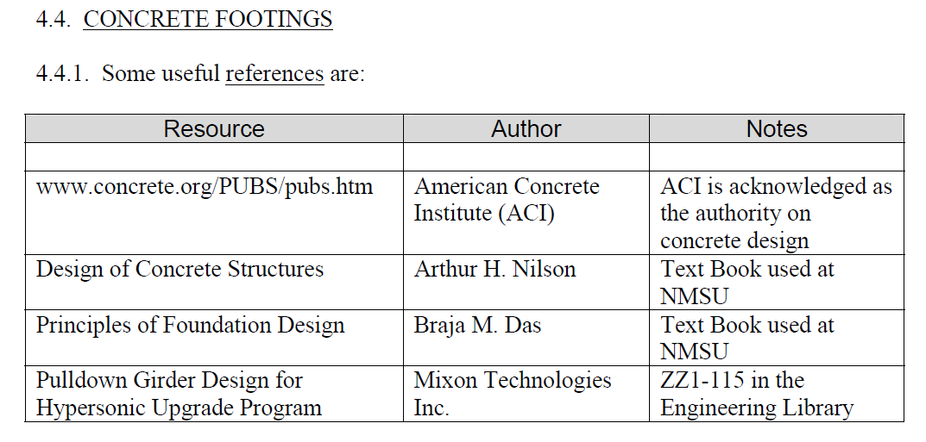

Fig 8.1 Useful References

**8.4.2. Loads:**

* + Footings designed at the track, particularly for rail pulldowns, must support dynamic and quasi-steady loads from sleds.
  + Rail pulldown footings experience dominant quasi-steady uplift loads, necessitating large mass to counteract uplift.
  + Lambda loads have proven effective in representing sled dynamic loads.

**8.4.3. Factor of Safety:**

* + A factor of safety (FS) of 1.5 has been sufficient in past applications for all components of the footing design.
  + This includes compressive stress in concrete, bearing stress in soil, and tensile stress in reinforcing steel.

**8.4.4. Soil Bearing Capacity:**

* + Designing footings with large bearing areas like pulldown footings can usually assume low soil bearing capacity due to load distribution.
  + Design loads of 1,500 psf or less have performed well historically, but geotechnical investigations can be obtained for more precise bearing capacity recommendations.

**8.4.5. Maintain Download:**

* + Correct sizing of footings is essential to ensure a download exists on the soil at all times, preventing soil erosion from beneath the footing.

**8.4.6. Concrete Mix Specifications:**

* + Special concrete mix designs resistant to sulfate attack and Alkali Silica Reaction (ASR) are specified to prevent premature concrete deterioration.
  + Sulfate attack originates from calcium sulfate (gypsum) in the area, while ASR results from reactive aggregates and alkali in cement.

**8.4.7. Concrete Strength:**

* + Structural concrete typically ordered at 3,000 psi is adequate for track purposes but can be increased to 4,000 or 5,000 psi when necessary.

**8.4.8. Cure Time:**

* + Concrete reaches half its specified strength in 7 days and its full specified strength in 28 days from the date of placement.
  + Higher strength concrete shortens the time required to reach design strength.

**8.4.9. Materials Testing:**

* + Structural concrete should be sampled and tested by qualified laboratories to certify its strength and other properties.

**8.4.10. Reinforcing Bar Joints:**

* + Rebar joints are typically made by overlapping sections of rebar a length equal to 36 bar diameters.
  + Rebar couplings and butt weld joints are also used, depending on the application.

**8.4.11. Anchor Bolts:**

* + Anchor bolts engaging vertical bars in the rebar cage are recommended for track use to resist tensile loads effectively.

**8.5. SCREENBOXES:**

**8.5.1. Definition:**

* + - Rocket motor staging and event initiation are typically accomplished electrically.
    - The HHSTT employs a pair of screenboxes, one positively charged and one negatively charged, to initiate events post-sled launch.
    - Screenboxes consist of aluminum screens stretched across the opening of a steel channel.
    - Screens are energized with 300 volts from a battery-powered capacitor-discharge fire box.
    - Knifeblades from the sled cut the screen, transferring voltage to initiate the appropriate event.
    - Screenboxes and their power supplies are placed trackside at the event location.
    - Drawings of screenboxes and associated hardware are filed under TFS 211.

**8.5.2. Backup (Redundant) Screen boxes:**

* + - Backup screen boxes should be used for all motor staging and event initiations when feasible.

**8.5.3. Screenbox Supports:**

* + - Adequate support structure between the rail and the screenbox must be designed for new test configurations.
    - This ensures that aerodynamic loads from passing sleds do not cause screenbox movement, preventing knifeblades from missing the screenboxes.

**9.0. SLED AND TEST DESIGN BEST PRACTICES**

**9.1. CROSS-TRACK WIND LIMITS**

**9.1.1. Monorail Sleds.** The maximum allowable cross-track wind limits, in knots, are as follows:

* + - Mach No. Up to 9” Dia Monorail Greater than 9” Dia Monorail
      * 0 - 3.0: 10 7
      * 3.0 - 5.0: 5 3
      * Above 5.0: 3 3

**9.1.2. Other Sleds.** Dual rail, outrigger, and narrow gage sleds generally do not have a wind limitation for structural considerations. Test requirements become the determining factor. Some large dual rail sleds such as MASE can be wind critical during handling and placing on the Track.

**9.2. Foams.** Open- and closed-cell foams have been used for various purposes at the HHSTT. Open-cell foam is generally used for isolating instrumentation packages and components. Open-cell foam comes in various densities and can generally be cut to the appropriate shape. Closed-cell foam has been used for braking media, light weight support structures, and sled models. Closed-cell foam also comes in various densities and can be cut to shape.

**9.3. VELOCITY MEASUREMENTS**

**9.3.1. Time and Position Systems.** Sled velocity along the track may be obtained using data from a number of systems. Raw position versus time data are generally obtained by time tagging the sled passing a discrete point on the track. The time and position data are used to compute an average value of velocity from one time tag to the next by the relationship velocity = Δs/Δt. The constant velocity value within each distance interval is assigned in a tabular listing such that the value appears to correspond to the interval leading time and its corresponding TS. The following time and position systems are commonly used.

**9.3.1.1. Space-Position Over Time System (SPOTS).** This system consists of a series of coil sensors permanently mounted to the rail web which detect ferromagnetic material in the vicinity of the slippers as sleds pass. The coil sensor locations are defined in Table 5.1 below. The signal is transmitted through the underground cable plant, and the Timer Programmer console records timing data. System accuracy has been shown to be better than 0.1% at 6,000 feet per second (fps), or ± 3fps. See Reference 5.2. System accuracy is highly dependent on several factors, and is limited largely by the system absolute timing accuracy of +1 msec (not including velocity-dependent sensor rise time and delay thru the cable plant). This system has been used to measure sled velocity up to 9400 ft/sec.

**9.3.1.2. Breakwire System.** This system consists of wire, typically 30 gauge, supported on foam blocks placed on the rail head. As the wires are broken by a passing sled, timing data are recorded through the Timer Programmer console. Up to 30 wires can be fielded anywhere along the track at specified locations. Placement accuracy is generally within +1/32 inch. This system has been used to measure sled velocity up to 9400 ft/sec. Note that a large number of breakwires on high speed sled tests has caused considerable, non-catastrophic, damage to slippers as well as slipper thermal protection.

**9.3.1.3. RR-200 Fiber-Optic System.** This system, configured entirely trackside, consists of optical fibers in special holders placed at surveyed locations. As the fibers are broken by a passing sled, timing data are recorded. Up to ten fiber-optic sensors may be fielded anywhere on the track, over approximately a 1500 ft maximum span of track. Fiber placement accuracy is generally within +1/32 inch. The system acquires absolute timing data with an accuracy of +2 microseconds. This system has been used to measure sled velocity up to 9465 ft/sec.

**9.3.1.4. Velocity Measuring System (VMS).** This system uses a sled-borne light-based sensor triggered by trackside fixtures (interrupter blades). These permanently installed interrupter blades are installed trackside at the locations shown in the Table 5.2 below. Blade-to-blade spacing is precisely surveyed using an interferometer. A sled-borne DAS or telemetry system is used to acquire timing data. The VMS heads are installed and removed at the sled launch and stop points respectively, and must be mounted in the forward region of the leading sled, preferably clear of slipper/rail debris and sled leading edge shock systems. The head design allows for limited horizontal and vertical excursions of the slipper gap and for irregularities in rail alignment. System accuracy has been shown to be 0.004% at 1500 ft/sec, or ± 0.03 ft/sec. See Reference 5.2. This system has been used to measure sled velocity up to 4000 ft/sec. Note that VMS has experienced unreliable (noisy) data in areas of the track with rail top and trough water brake media, or if the track facility is wet from precipitation.

**9.3.2. Photo-Optic Systems.** Velocity may also be determined from photo-optic data sources such as Fixed (FX) cameras and Image Motion Compensation (IMC) cameras.

* + - Here, velocity is determined by dividing the known size, typically length, of the object in the film by the difference in timing of the object's leading and trailing edges. Timing data are recorded on the film. IMC cameras have been used to measure sled velocity up to 9465 ft/sec.
    - The Trajectory Information System (TIS) may serve as the primary source of trajectory data of sled and test items separating in three-dimensional space. The TIS has been used to measure sled velocity up to approximately 1400 ft/sec.

**9.4. Velocity Window.** The Velocity Window is a feature of the Timer/Programmer in the Track Data Center (TDC). Its purpose is to verify that the sled’s velocity is within an allowable range just prior to it reaching the screenbox that initiates the event. The Timer/Programmer accomplishes this by comparing the time the sled takes to travel between two breakwires placed on the railhead of the track. It compares this time to the acceptable range of times that the sled would take if it was traveling above the minimum velocity and below the maximum velocity. If the time is in the acceptable range, the Timer/Programmer enables the screenbox power supply to energize the screenbox and thus initiate the event. If the time is outside the acceptable range, the screenbox is left de-energized and the sled passes through with no event initiation. The Velocity Window can be placed anywhere along the track. It has been successfully used up to 1400 ft/sec.

**9.5. PROPULSION**

**9.5.1. Motor mounting provisions** shall be designed to permit loading of the motor(s) by use of an overhead crane.

**9.5.2. Motor mount(s), attachments, and sled structure** shall be designed to allow for longitudinal and radial motor case expansion appropriate for the motor(s) used.

**9.5.3. Motor case(s) may be used as a structural member.** However, the designer shall analyze the motor case(s) to ensure that combined stress levels remain within specified limits for all operating conditions.

**9.5.4. No structure shall extend aft of the rear nozzle exit plane** except for the water brake and push pad structure, if mounted on the aft beam of the sled.

**9.5.5. Forward Motor Mounting**

**9.5.5.1. All forward motor mounting fitting(s)** shall be designed to eliminate or minimize bending moments induced in the motor case(s) due to the sled structural deformation or dynamic loads during all operating conditions.

**9.5.5.2. The motor case(s) shall be analyzed** to ensure it is capable of sustaining induced moments within specified material strength margins of the motor case(s).

**9.5.6. Aft Motor Mounting.** All aft motor supports shall accommodate thermal growth in motor case length appropriate to the motor(s) used.

**9.5.7. Misfire Conditions.** All sleds operating with motors shall be designed to sustain, without structural damage, asymmetric loadings due to all possible misfire motor combinations.

**9.5.8. Propulsion Wiring**

**9.5.8.1.** All wiring used for motors will be routed through conduit to the maximum extent practical.

**9.5.8.2. Motor mount(s), attachments, and sled structure shall be designed** to allow for easy access to the motor igniter and its wiring after the motor(s) have been installed.

**9.5.9. Available Motors.** Table 5.3 provides a listing of the rocket motors commonly used by the HHSTT. Detailed information for each rocket motor is maintained by the propulsion manager.